## **Ideation Phase**

**Define the Problem Statements**

|  |  |
| --- | --- |
| Date | 21 June 2025 |
| Team ID | LTVIP2025TMID53034 |
| Project Name | Docspot |
| Maximum Marks | 2 Marks |

**Customer Problem Statement**

* **Who is experiencing the problem?** Freelancers—ranging from beginners to seasoned professionals in fields like design, writing, technology, and marketing—face persistent challenges in discovering reliable and rewarding job opportunities. They seek a streamlined, trustworthy platform to quickly find legitimate, relevant, and fairly compensated freelance work.
* **However, their efforts are often blocked by:**

Overcrowded job platforms with irrelevant or poor-quality listings

Scam or unclear postings with unrealistic expectations or low pay

Lack of transparency from clients and delayed communication

Difficulty building trust and effectively showcasing their portfolio

Excessive competition, often leading to underpricing and burnout

As a result, freelancers are forced to juggle multiple job boards, social media groups, and aggregators—often spending more time searching than actually working. This not only affects their productivity but also leaves them frustrated, anxious, and uncertain about long-term freelance sustainability.

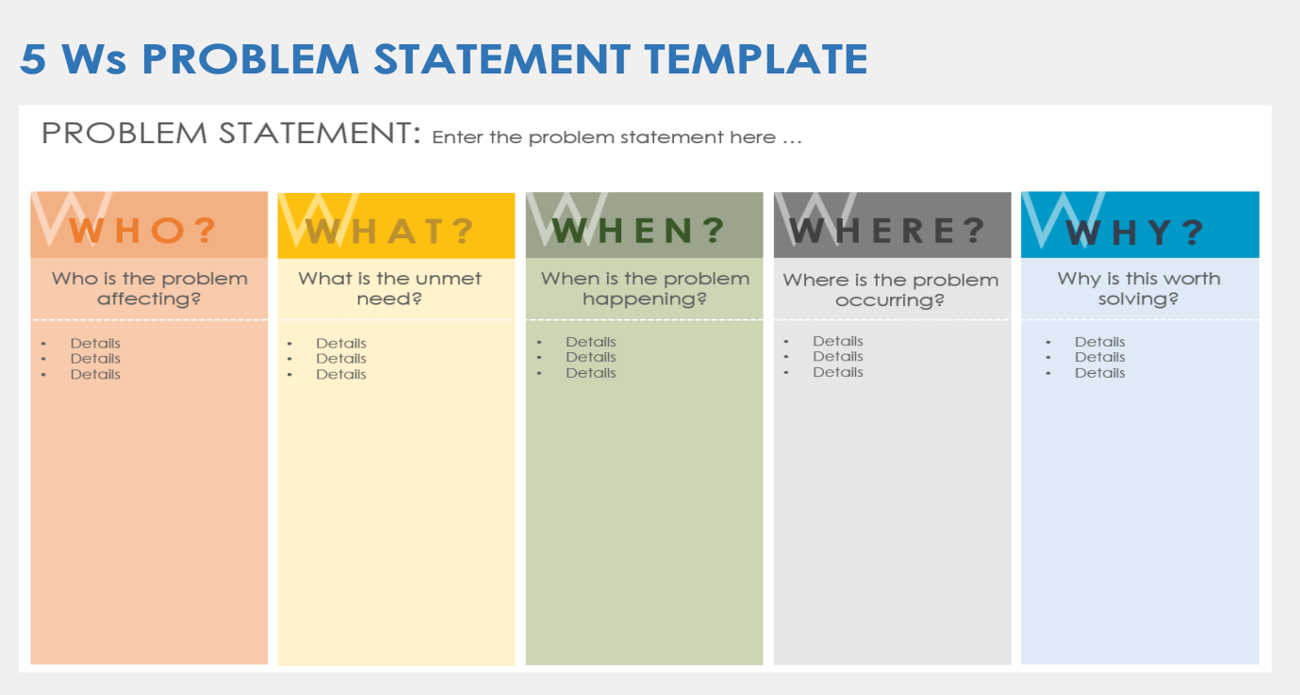

|  |  |  |  |  |  |
| --- | --- | --- | --- | --- | --- |
| **Problem Statement (PS)** | **I am (Customer)** | **I’m trying to** | **But** | **Because** | **Which makes me feel** |
| PS-1 | a freelancer trying to build a stable career | find high-quality, legitimate freelance jobs efficiently | most platforms are crowded with irrelevant or low-paying listings | they lack proper filtering and allow scam or outdated postings | frustrated, demotivated, and unsure if freelancing is sustainable for me.. |
| PS-2 | a skilled designer new to freelancing | get visibility and land my first few projects | my profile gets overlooked and clients don't trust newcomers easily | the platform doesn’t highlight skills or potential, only past reviews | makes me feel discouraged and stuck despite having talent.  . |